DNA sequence classification

Abstract— DNA sequence classification is a key task in bioinformatics. It involves identifying functional regions within DNA sequences using computational methods. Promoter regions are specific DNA sequences that start gene transcription. They are essential for gene regulation and expression. Identifying promoter regions accurately is crucial for predicting genes, researching diseases, discovering drugs, and understanding genetic regulatory mechanisms. Traditional biological methods for identifying promoters are time-consuming, expensive, and need expert knowledge. This necessity makes automated computational approaches important for handling large genomic datasets. In this project, we developed deep learning models to classify DNA sequences as promoter or non-promoter regions. The dataset consists of DNA sequences, each with a fixed length of 251 base pairs, made up of the nucleotides Adenine, Thymine, Cytosine, and Guanine. We converted the DNA sequences into numerical format using one-hot encoding. This process transforms each nucleotide into a binary vector representation. The encoded sequences served as input for the deep learning models. We implemented and compared three deep learning architectures: Convolutional Neural Network (CNN), Long Short-Term Memory (LSTM), and a hybrid CNN-BiLSTM model. The CNN model detects local sequence motifs, the LSTM model captures sequential dependencies in DNA sequences, and the CNN-BiLSTM model combines local feature extraction with sequential learning. We trained the models on a training dataset and evaluated them on a testing dataset using metrics like accuracy, precision, recall, F1-score, ROC-AUC, confusion matrix, and classification report. The results show that the CNN model performed the best among the three models, achieving an accuracy of about 87.78% and a ROC-AUC of around 0.94. The CNN-BiLSTM model performed moderately, while the LSTM model performed worse than the CNN. These results suggest that promoter classification relies more on local DNA sequence motifs, which convolutional neural networks can capture effectively. The confusion matrices, ROC curves, and training graphs further confirm that the CNN model outperforms the other models in classification. This project shows that deep learning models can classify DNA sequences and identify promoter regions accurately. The approach is useful for genomic sequence analysis, gene regulation studies, disease research, and bioinformatics applications. Future work includes fine-tuning hyperparameters, utilizing deeper and more complex architectures, such as transformer models, and deploying the model as a web application for real-time DNA sequence classification.
Keywords—component, formatting, style, styling, insert (key words)

Introduction
DNA sequence classification is a key task in bioinformatics. It involves identifying functional regions in DNA sequences with computational methods. DNA consists of four nucleotide bases: Adenine, Thymine, Cytosine, and Guanine. Together, these bases form the genetic code for living organisms. DNA sequences contain biological information that affects gene expression, protein production, and cellular behavior. Understanding these sequences is vital for gene identification, disease research, and grasping biological processes. With improvements in sequencing technologies, a vast amount of genomic data is generated daily. Although sequencing DNA has become quicker and cheaper, analyzing and interpreting this genomic data is still a tough challenge. Traditional laboratory methods for DNA analysis are slow and costly, which makes automated computational approaches essential. Machine learning and deep learning offer strong tools for analyzing DNA sequences. They can learn patterns from biological data automatically without the need for manual feature extraction. In this project, we developed deep learning models to classify DNA sequences as promoter or non-promoter regions. Promoter regions are crucial DNA segments that control the start of gene transcription. Identifying these regions aids in gene prediction, disease analysis, and drug discovery. We converted the DNA sequences into numerical format using one-hot encoding. Then, we used these as input for CNN, LSTM, and CNN-BiLSTM models. The models were trained and assessed with various evaluation metrics, including accuracy, precision, recall, F1-score, ROC curve, and confusion matrix.

Problem statement
The rapid increase in genomic data from next-generation sequencing technologies has created a need for automated methods to classify DNA sequences. DNA sequencing is quick, but understanding DNA sequences and identifying important areas, like promoter regions, is still challenging. Analyzing DNA sequences by hand requires expert knowledge and takes a lot of time, making it impractical for large genomic datasets. Promoter regions play a crucial role because they control gene expression and transcription. Accurately identifying these regions is vital for understanding gene regulation and disease processes. Traditional methods for finding promoters rely on biological experiments and motif searching techniques, which are slow and may not always yield accurate results. This project aims to create a deep learning model that can automatically sort DNA sequences into promoter and non-promoter categories. A key challenge is that DNA sequences are text-based data and need to be converted into numerical form before they can be used in machine learning models. Another difficulty is choosing the right deep learning architectures that can effectively learn patterns from these sequences.

motivation
The rapid growth of genomic data from next-generation sequencing technologies has created a need for automated methods to classify DNA sequences. DNA sequencing is fast, but interpreting DNA sequences and pinpointing key areas, like promoter regions, remains challenging. Analyzing DNA sequences manually requires expert knowledge and is time-consuming, making it impractical for large genomic datasets. Promoter regions are important because they control gene expression and transcription. Identifying these regions is essential for understanding gene regulation and disease processes. Traditional methods for finding promoters depend on biological experiments and motif searching techniques, which are slow and may not always produce reliable results. This project aims to develop a deep learning model that can automatically categorize DNA sequences into promoter and non-promoter groups. A major challenge is that DNA sequences are text-based data and must be converted into numerical form before being used in machine learning models. Another issue is selecting the right deep learning architectures that can effectively learn patterns from these sequences.

dataset description
The project dataset comprises DNA sequences which researchers have designated as either promoter sequences or non-promoter sequences. DNA sequences consist of four nucleotide bases which include Adenine (A) Thymine (T) Cytosine (C) and Guanine (G). The nucleotide bases create the genetic code which governs all living organisms and particular patterns in DNA sequences lead to functional areas that include genes and promoters and enhancers and regulatory elements. The dataset aims to train deep learning models which will identify promoter regions and non-promoter regions in DNA sequences. The dataset contains DNA sequences of fixed length, where each sequence contains 251 nucleotide bases. Deep learning models require input sequences of the same size, which makes fixed sequence length essential. All sequences must reach uniform length through padding or truncation when their original lengths differ. The dataset contains sequences which already meet the required length, thus enabling efficient preprocessing and model training procedures. The dataset contains a total of 36,131 DNA sequences. The deep learning models used approximately 27,097 sequences for training, while the testing and evaluation process utilized 9,034 sequences. The dataset consists of two separate classes which include promoter sequences and non-promoter sequences. The DNA regions that start gene transcription are known as promoter sequences, while non-promoter sequences describe DNA regions that prevent transcription from starting. The dataset contains DNA sequences which researchers have labeled as either promoter sequences or non-promoter sequences. The model training uses these labels to help deep learning models understand the patterns which exist in promoter regions while learning to separate them from non-promoter areas.

Methodology
The methodology used in this project involves several steps, including dataset acquisition, data preprocessing, sequence encoding, model development, model training, model evaluation, and prediction. The main objective of this methodology is to create deep learning models which can categorize DNA sequences as either promoter or non-promoter regions. The methodology starts with raw DNA sequences and concludes with model predictions and performance evaluation through its structured workflow. The first step in the methodology is dataset acquisition. The project uses a dataset which contains DNA sequences that researchers have marked as either promoter or non-promoter sequences. The DNA sequence consists of 251 base pairs which include the nucleotides Adenine Thymine Cytosine and Guanine. The dataset contains a total of 36,131 DNA sequences. The sequence data included for model training consisted of 27,097 sequences while 9,034 sequences served for model testing. The dataset contains two classes: promoter and non-promoter. The training dataset was used to train the models, and the testing dataset was used to evaluate the performance of the models.

The researchers will begin data preprocessing after they obtain the dataset. The raw DNA sequences require processing because they need to become suitable inputs for deep learning models. The DNA sequences need conversion from their text-based biological form because machine learning models require numerical data for processing. The process of data preprocessing starts with dataset cleaning while maintaining uniform sequence length and transforming sequences into numerical format through encoding methods.

The next step in the methodology is sequence encoding. The researchers converted DNA sequences into numerical format through one-hot encoding because deep learning models need numeric data for processing. One-hot encoding converts each nucleotide into a binary vector representation. In one-hot encoding system nucleotide A appears as [1,0,0,0] while nucleotide C appears as [0,1,0,0] and nucleotide G appears as [0,0,1,0] and nucleotide T appears as [0,0,0,1]. After the encoding process, DNA sequences transform into matrices that have dimensions of 251 by 4. The matrix serves as the numerical representation of the DNA sequence which deep learning models use as input.

The one-hot encoding process maintains both the location and the identity of every nucleotide present in the DNA sequence. The DNA sequence nucleotide positions serve as a critical factor which aids in promoter detection. The system used DNA sequences which were transformed to encoded form and stored in array data structure for purposes of training the models. The methodology proceeds to model development after the DNA sequences have been encoded. The project required the creation of three deep learning models which included Convolutional Neural Network (CNN) and Long Short-Term Memory (LSTM) and hybrid CNN-BiLSTM model.

Architecture

The researchers developed the model to extract patterns from DNA sequences and identify promoter and non-promoter DNA sequences. The CNN model was developed to find local DNA sequence patterns and specific motifs. The specific motifs which exist in promoter regions can be detected through the application of convolution filters. The CNN model comprises convolution layers activation functions pooling layers flatten layer dense layer dropout layer and output layer. The convolution layers use filters to analyze DNA sequences and identify patterns. The ReLU activation function introduces non-linearity into the model. The max pooling layer reduces the dimensionality of the feature maps and extracts important features. The flatten layer converts the feature maps into a vector, which is passed to the dense layer for classification. The dropout layer prevents overfitting by randomly dropping neurons during training. The output layer utilizes sigmoid activation to make a sequence classification between promoter and non-promoter categories.

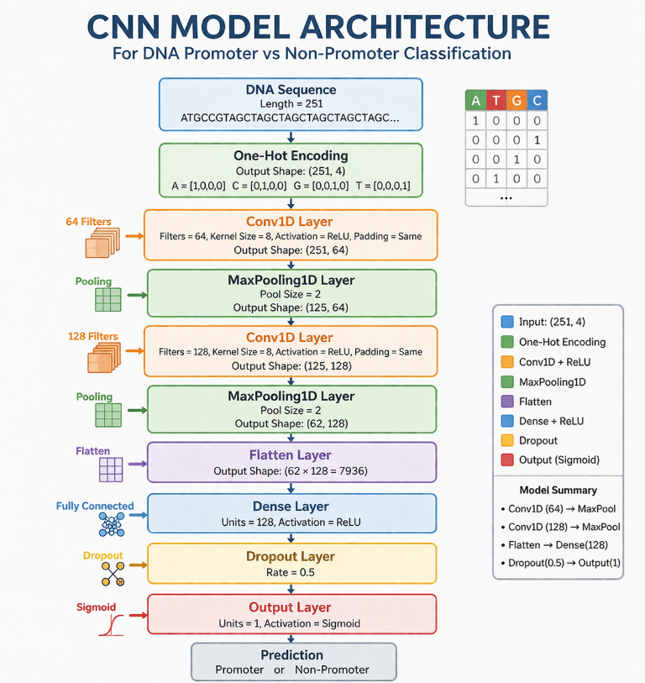

The project employs its second model through the establishment of the LSTM model. The Long Short-Term Memory model is designed for sequential data and is capable of learning long-term dependencies in sequences. The LSTM model enables DNA sequence analysis because DNA sequences function as sequential data which LSTMs use to discover relationships between nucleotides throughout the entire sequence. The LSTM model consists of an LSTM layer followed by dense and dropout layers. The LSTM layer processes the DNA sequence sequentially and learns patterns from the sequence. The dense layer performs classification, and the dropout layer prevents overfitting. The output layer produces the final classification result.

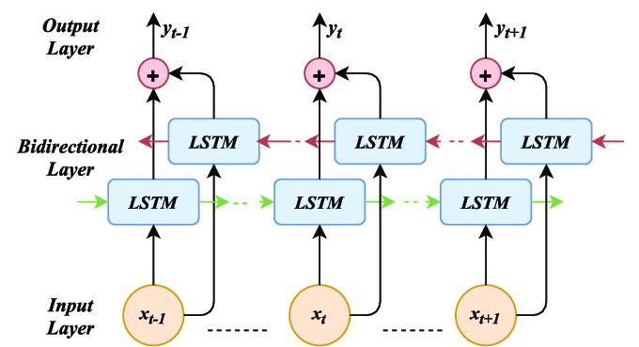

The third model used in this project is the CNN-BiLSTM model which is a hybrid model that combines convolution layers and bidirectional LSTM layers. The convolution layers extract local features from DNA sequences and the bidirectional LSTM layer learns sequence dependencies in both forward and backward directions. This hybrid model combines the advantages of CNN and LSTM models. The CNN-BiLSTM model first extracts features using convolution layers and then passes the features to a bidirectional LSTM layer which processes the sequence in both directions. The dense layer and dropout layer perform classification and prevent overfitting. The output layer predicts whether the sequence is promoter or non-promoter.

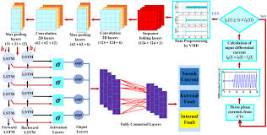

evaluation
The project assessed performance of its deep learning models through multiple evaluation metrics and different visualization methods. The evaluation process aimed to assess which model between CNN, LSTM, and CNN-BiLSTM showed the highest performance for DNA promoter classification. The models underwent assessment through six metrics which included accuracy, precision, recall, F1-score, and ROC-AUC together with the confusion matrix and training and validation loss curves and training and validation AUC curves. Machine learning model evaluation functions as a crucial procedure since classification model performance assessment requires multiple evaluation methods to measure accuracy in biological sequence classification tasks. The researchers employed multiple assessment metrics to evaluate model performance from various evaluation aspects.

Evaluation Metrics

The evaluation team utilized multiple assessment metrics to measure the modeling results. The model accuracy assesses total system correctness through its calculation of correctly forecasted instances divided by all instances. Precision measures how many predicted promoter sequences are actually promoter sequences. The model evaluation of actual promoter sequences shows how many of these sequences were successfully identified. The F1-score calculates the harmonic mean between precision and recall to create a metric that unites both performance measurements. The ROC-AUC metric evaluates how well the model can separate promoter and non-promoter categories at various threshold levels. The accuracy metric fails to provide an accurate assessment of model effectiveness because it does not handle situations where different classes have different distribution patterns. The combination of precision and recall metrics demonstrates how effectively the model detects actual promoter sequences while avoiding incorrect predictions. The F1-score provides a balanced measure of model performance. The ROC-AUC metric evaluates the complete classification effectiveness of a system without depending on specific classification thresholds.

Model Performance Comparison

The researchers evaluated the three models by using accuracy and precision and recall and F1-score and ROC-AUC metrics for their performance assessment. The CNN model achieved the highest performance among the three models. The CNN model achieved approximately 87.78% accuracy and precision of approximately 0.918 and recall of approximately 0.851 and F1-score of approximately 0.883 and ROC-AUC of approximately 0.941. The CNN-BiLSTM model achieved moderate performance with accuracy around 78% while the LSTM model achieved lower performance with accuracy around 74%. These results indicate that the CNN model performs better than the LSTM and CNN-BiLSTM models for DNA promoter classification. This study shows that promoter classification needs local sequence patterns and motifs as its primary requirement rather than long-range sequence dependencies. CNN models detect local patterns through their convolution filters which leads to their superior project performance.
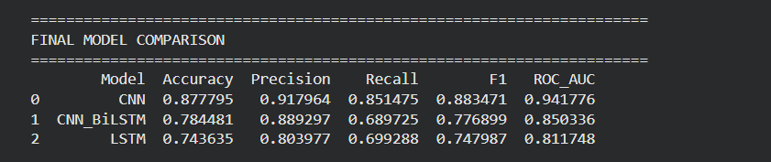

The model comparison graph shows that all evaluation metrics measure higher values for the CNN model than for the LSTM and CNN-BiLSTM models. The ROC-AUC score for CNN shows a significant increase which demonstrates its superior ability to classify data.

Confusion Matrix Analysis

The confusion matrix evaluates the classification performance of models through its display of correct and incorrect predictions which it provides for each class. The confusion matrix contains four values: true positives, true negatives, false positives, and false negatives. True positives represent promoter sequences which were accurately identified as promoters. True negatives represent non-promoter sequences which were accurately identified as non-promoters. False positives represent non-promoter sequences which were wrongly identified as promoters. False negatives represent promoter sequences which were wrongly identified as non-promoters.

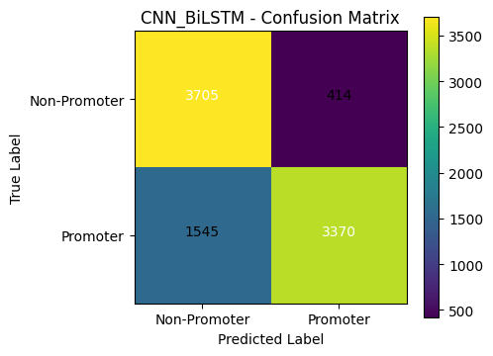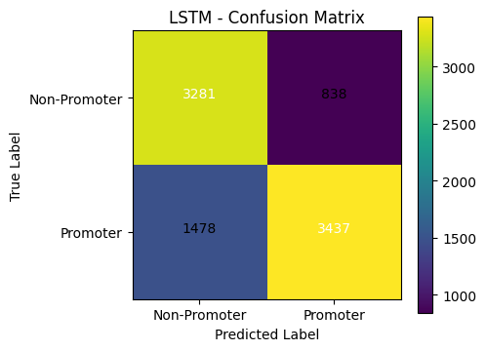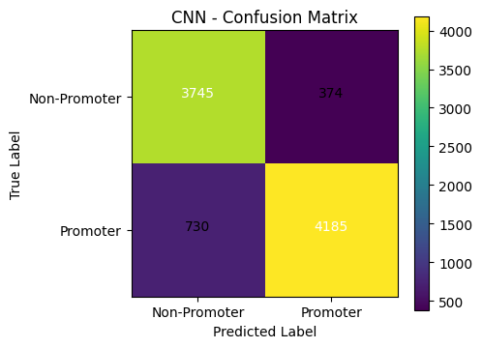

The confusion matrix results show that the CNN model achieved better results than LSTM and CNN-BiLSTM models because it successfully identified most promoter and non-promoter sequences with less misidentification. The CNN model shows improved classification results through its greater total of true positive and true negative results. The LSTM model has more misclassifications compared to CNN which explains its lower accuracy. The CNN-BiLSTM model performs better than LSTM but still not as well as CNN. The confusion matrix analysis shows that the CNN model is better at distinguishing between promoter and non-promoter sequences compared to the other models.

ROC Curve Analysis

The ROC curve helps assess model classification accuracy by displaying true positive rates and false positive rates across multiple classification thresholds. The ROC curve helps visualize how well the model separates the two classes. The area under the ROC curve (AUC) represents the overall performance of the model. A higher AUC value indicates better classification performance.

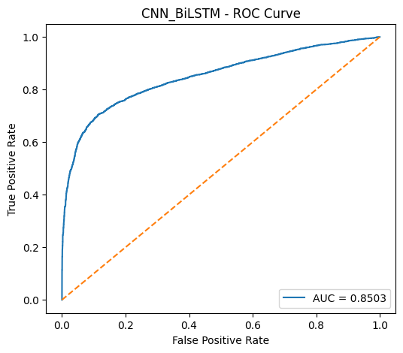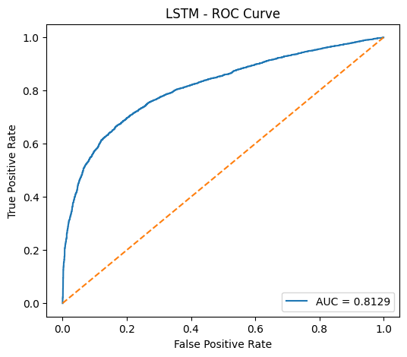

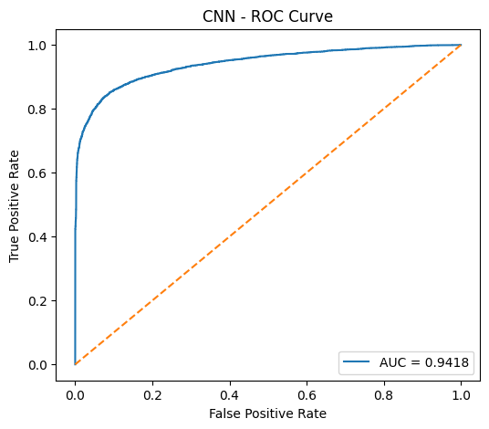

The CNN model exhibits superior classification ability through its highest ROC curve and maximum AUC value, which surpasses the performance of both CNN-BiLSTM and LSTM models. The three models show different levels of ROC performance, with CNN-BiLSTM achieving moderate results and LSTM recording the lowest performance.

The CNN model demonstrates the highest performance in DNA promoter classification according to ROC-AUC values.

Training and Validation Loss Analysis

The analysis of model development during training uses training and validation loss curves as their primary evaluation method. The training loss shows the model's ability to match the training data, while the validation loss shows the model's performance on new data that it has not encountered before. 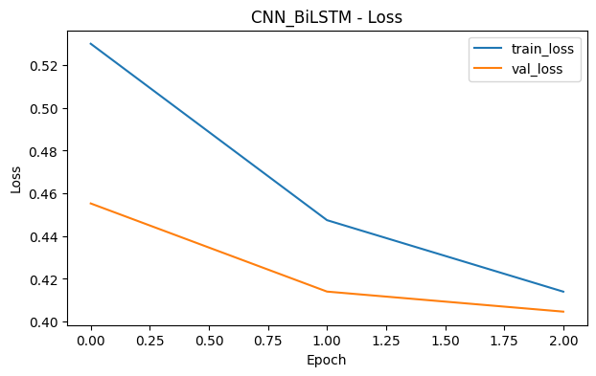

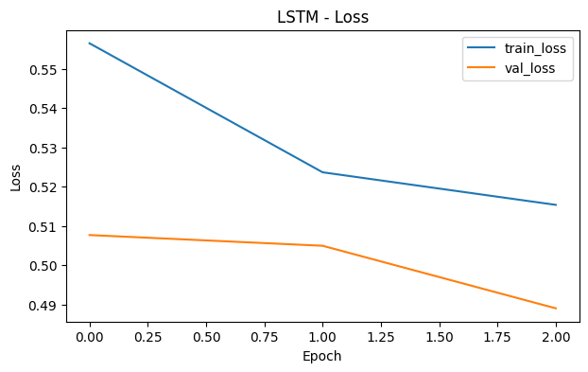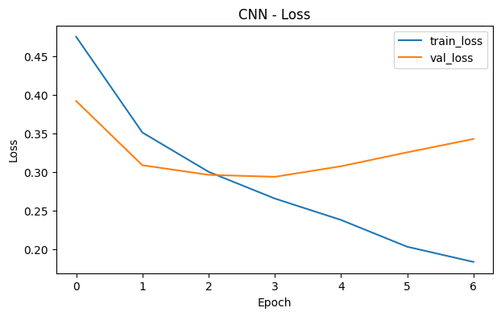
The training and validation loss curves show that the loss decreases as the number of epochs increases which indicates that the models are learning patterns from the DNA sequences. The validation loss does not increase significantly which indicates that the models are not overfitting significantly. The CNN model shows stable convergence compared to LSTM and CNN-BiLSTM models.

Training and Validation AUC Analysis

The training process and validation AUC curves demonstrate how classification accuracy improves through training progress. The AUC values show improvement because the model develops superior classification abilities.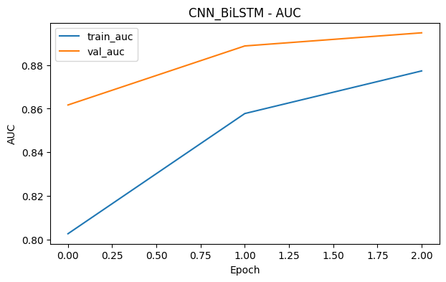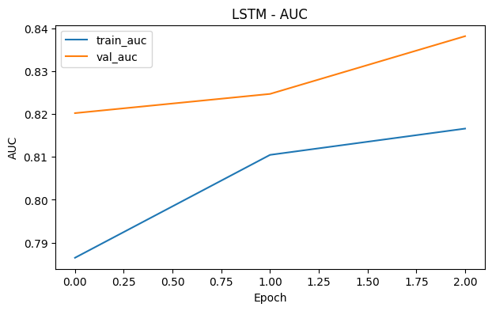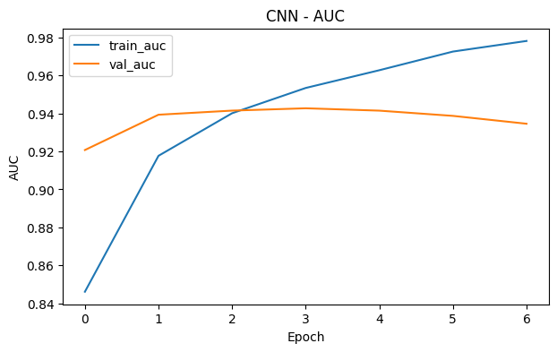
The training and validation AUC curves show that the CNN model achieved the highest AUC values compared to the LSTM and CNN-BiLSTM models. The AUC values increased through training epochs until they reached a stable point which showed that the models had successfully learned to classify data.

Classification Report Analysis

The classification report provides detailed evaluation metrics which include precision and recall and F1-score and support for each class. The CNN model achieved higher precision and recall and F1-score results for both promoter and non-promoter classes when compared to the LSTM and CNN-BiLSTM models. The weighted average F1-score for CNN was higher than the other models, indicating better overall classification performance. The CNN-BiLSTM model performed better than the LSTM model but did not outperform the CNN model. The LSTM model showed lower precision and recall values when compared to the CNN model which resulted in decreased accuracy and F1-score.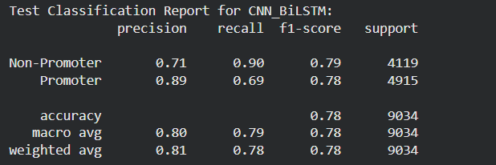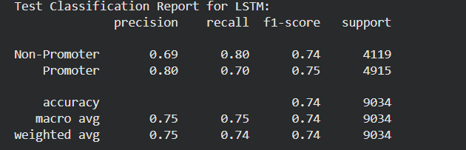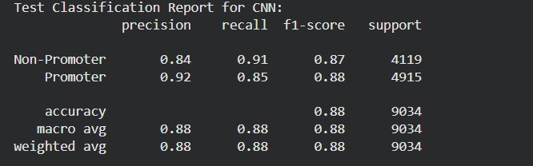

Overall Evaluation Summary

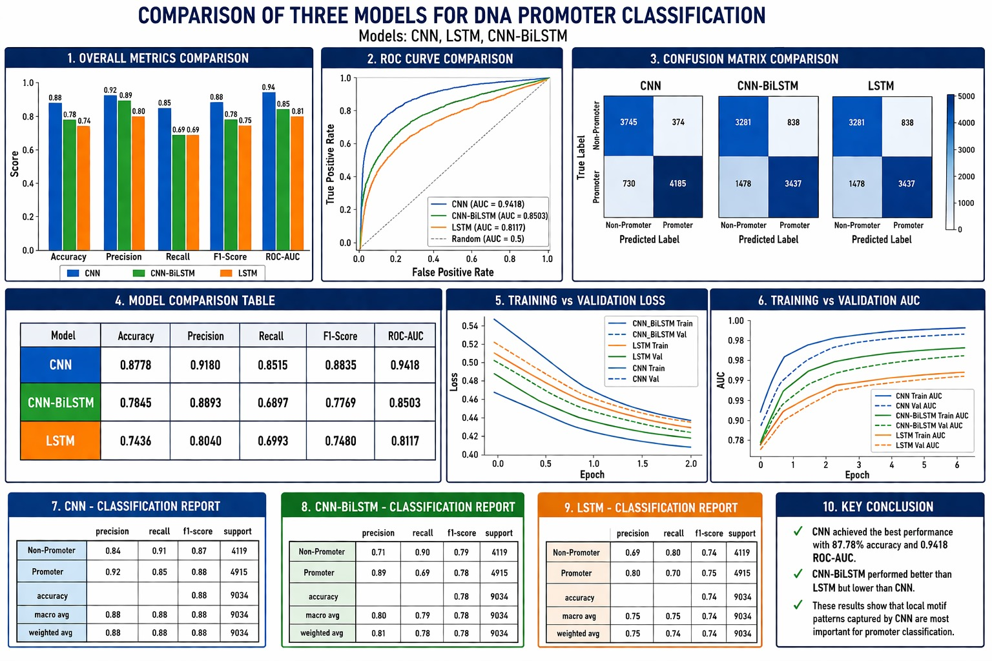

The CNN model performed better than the two other models according to the final evaluation results. The CNN model achieved the highest accuracy, precision, recall, F1-score, and ROC-AUC values. The CNN model demonstrates superior performance to LSTM and CNN-BiLSTM models according to the confusion matrix, ROC curve, training curves, and classification report.

The results suggest that promoter classification depends more on local DNA sequence motifs rather than long-range sequence dependencies. The CNN model achieved its best performance because Convolutional Neural Networks detect local patterns which exist in DNA sequences.

The evaluation results demonstrate that deep learning models can successfully classify DNA sequences and identify promoter regions with good accuracy and performance. The CNN model is the most suitable model for DNA promoter classification among the models tested in this project.

The CNN model achieved the highest accuracy among the three models. The CNN model achieved approximately 87.78% accuracy and ROC-AUC of approximately 0.94. The CNN-BiLSTM model achieved approximately 78% accuracy, and the LSTM model achieved approximately 74% accuracy. The results show that CNN performed better than LSTM and CNN-BiLSTM for DNA promoter classification.
The confusion matrix shows that the CNN model correctly classified most promoter and non-promoter sequences with fewer misclassifications compared to other models. The ROC curve also shows that the CNN model has the highest AUC value, indicating better classification performance. The training and validation loss graphs show that the models converged during training and did not overfit significantly.

Conclusion
The researchers created deep learning models to identify DNA sequences as either promoter regions or non-promoter regions in this study. The researchers transformed DNA sequences into numerical data through one-hot encoding which served as input for their CNN LSTM and CNN-BiLSTM models. The training of models included different evaluation methods which assessed their performance through accuracy calculations and precision tests and recall assessments and F1-score measurement and ROC-AUC testing and confusion matrix analysis and classification report generation.

The CNN model demonstrated superior performance among the three models when it achieved the highest accuracy and ROC-AUC score. Convolutional neural networks can effectively capture local DNA sequence motifs which scientists use to classify promoter regions in their research. The research findings show that deep learning models can accurately identify promoter regions in DNA sequences which helps scientists study genomic sequences and gene regulation.

Future work
Future work for this project includes hyperparameter tuning to improve model performance, using deeper and more advanced architectures such as attention-based models and transformer models, and deploying the model as a web application or API so that users can input DNA sequences and get predictions. Additional datasets will help the model to improve its generalization capability and performance level.

References

- Alipanahi, B., et al. (2015). Predicting the sequence specificities of DNA- and RNA-binding proteins by deep learning. Nature Biotechnology.
- Ji, Y., et al. (2021). DNABERT: pre-trained Bidirectional Encoder Representations from Transformers model for DNA-language in genome. Bioinformatics.
- LeCun, Y., Bengio, Y., & Hinton, G. (2015). Deep learning. Nature.

